**DNS**

DNS is like we save mobile number with their name so it is easy for us

**A Record:** Record that holds the IP address of domain

**CName:** Forward one domain or sub domain to another domain, Does not provide Ip address

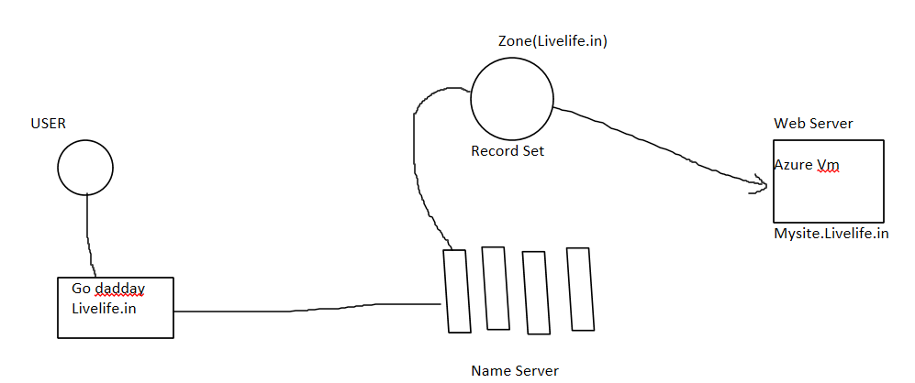

Here user want to access web server

User send request and first request go to external DNS (godaddy) where it check zone in azure DNS it’s name servers entry is there or not if there than it go to azure DNS zone it check that record(mysite.livelife.in) is there or not if there than route to that website.

**Public DNS:**

One application that we want to access over internet publicly

In private we access within network

**Configuration:**

Create one VM

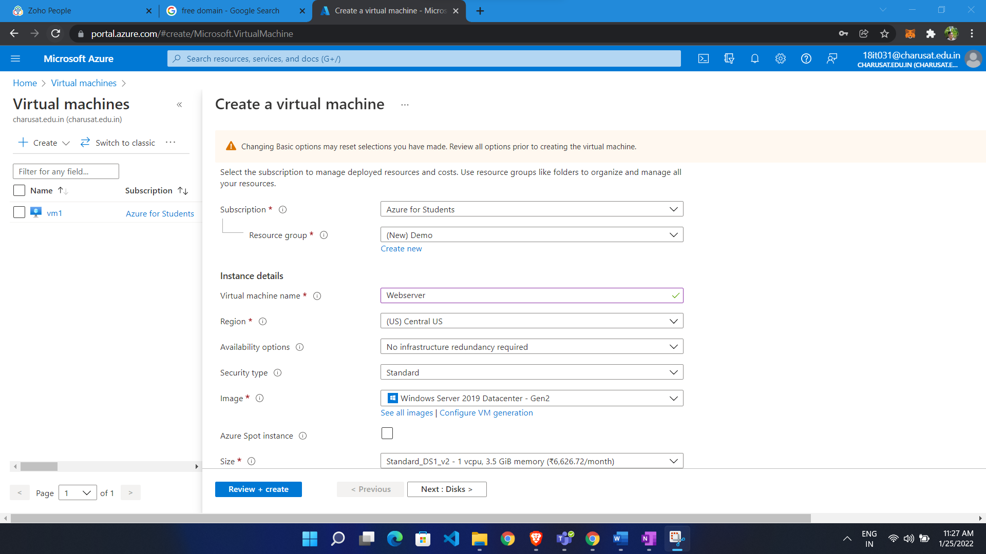

Now make DNS ZONE:

* Go to portal
* Search dns zone and go to DNS zone
* Click create
* Choose resource group
* Give name ( Name is which domain we purchased )

We get one custom domain

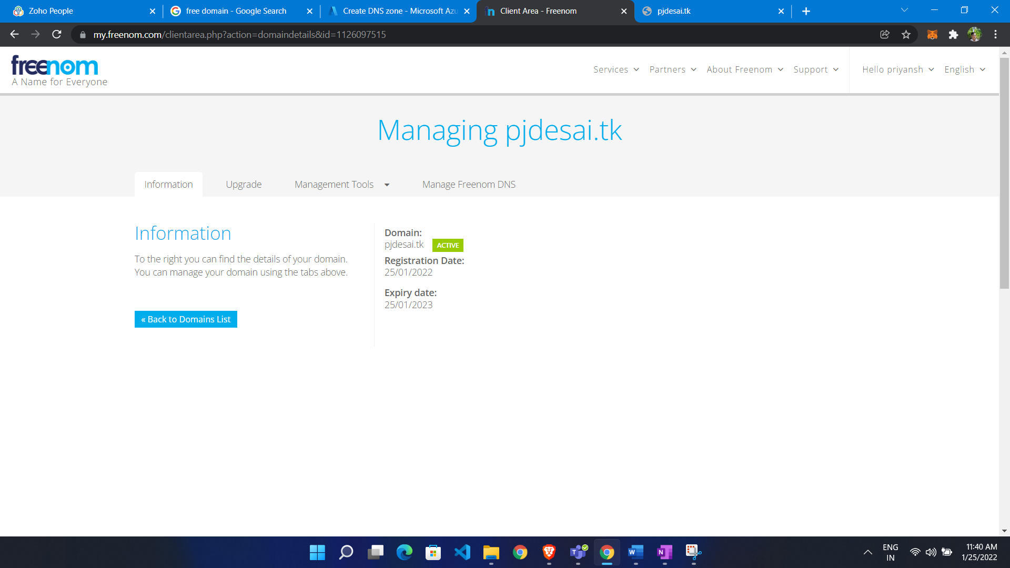

* Put pjdesai.tk in name field

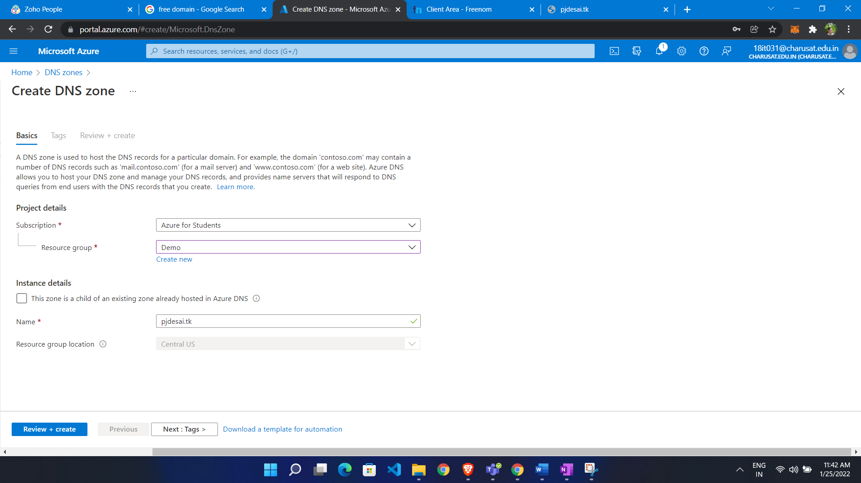

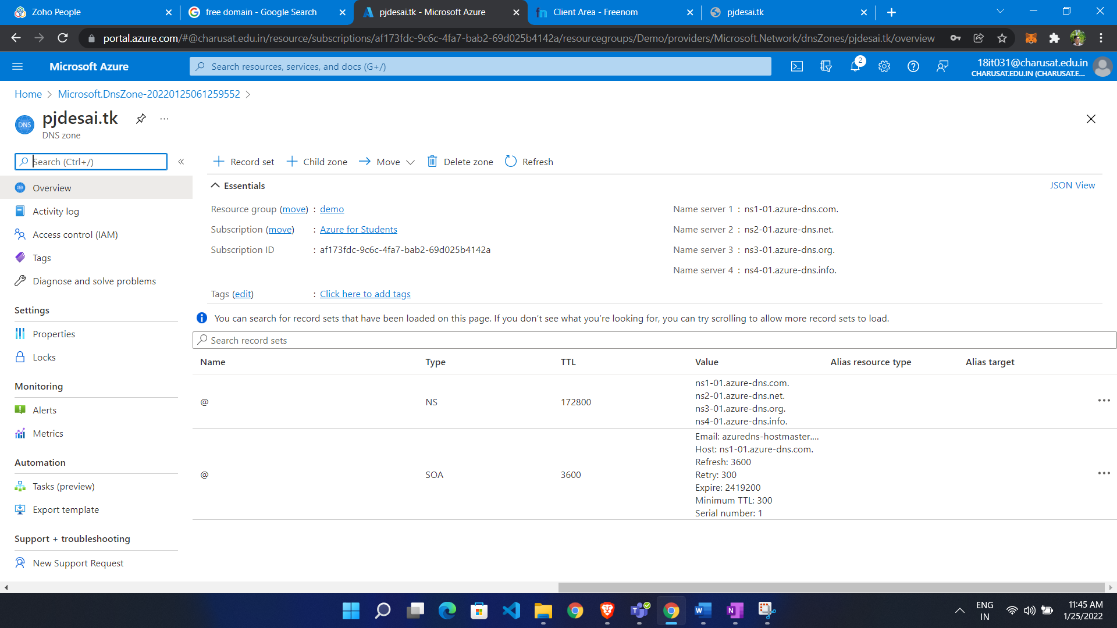

Now do Entry of name server to custom domain:

* Go to custom domain
* Go to management tool and click name server

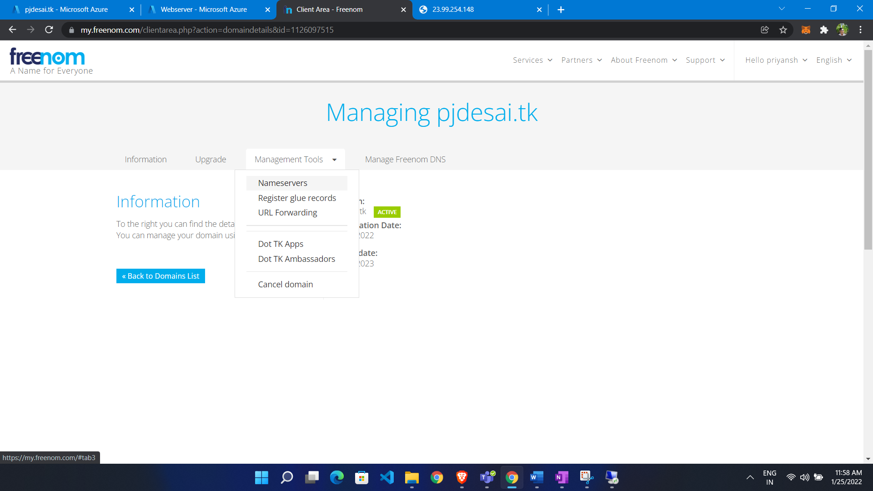

Click use custom name server and enter our name server

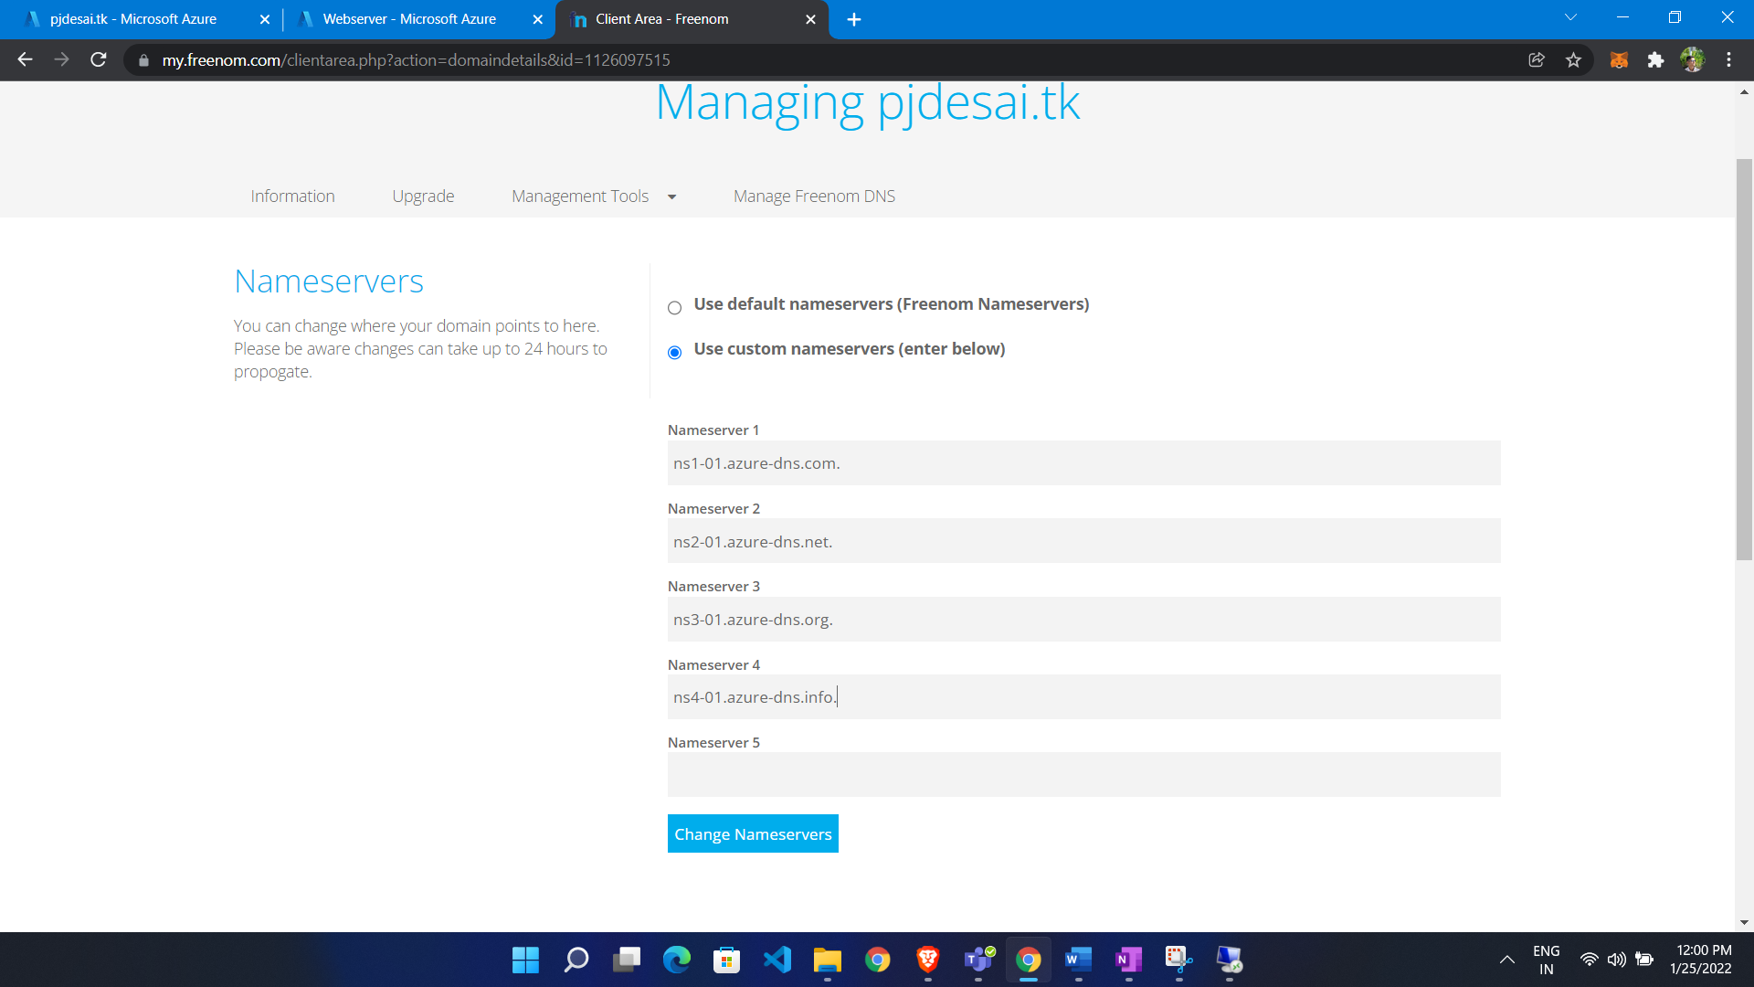

Now make Record:

* Go to DNS Zone
* Click Record set icon
* Give name ( if you want to it before your domain name)
* Select record type
* Give ip ( public IP of VM) it must be static

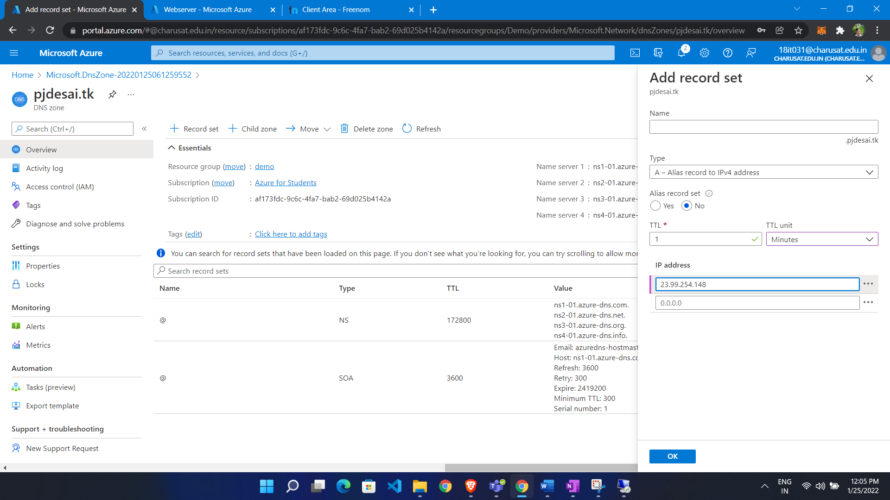

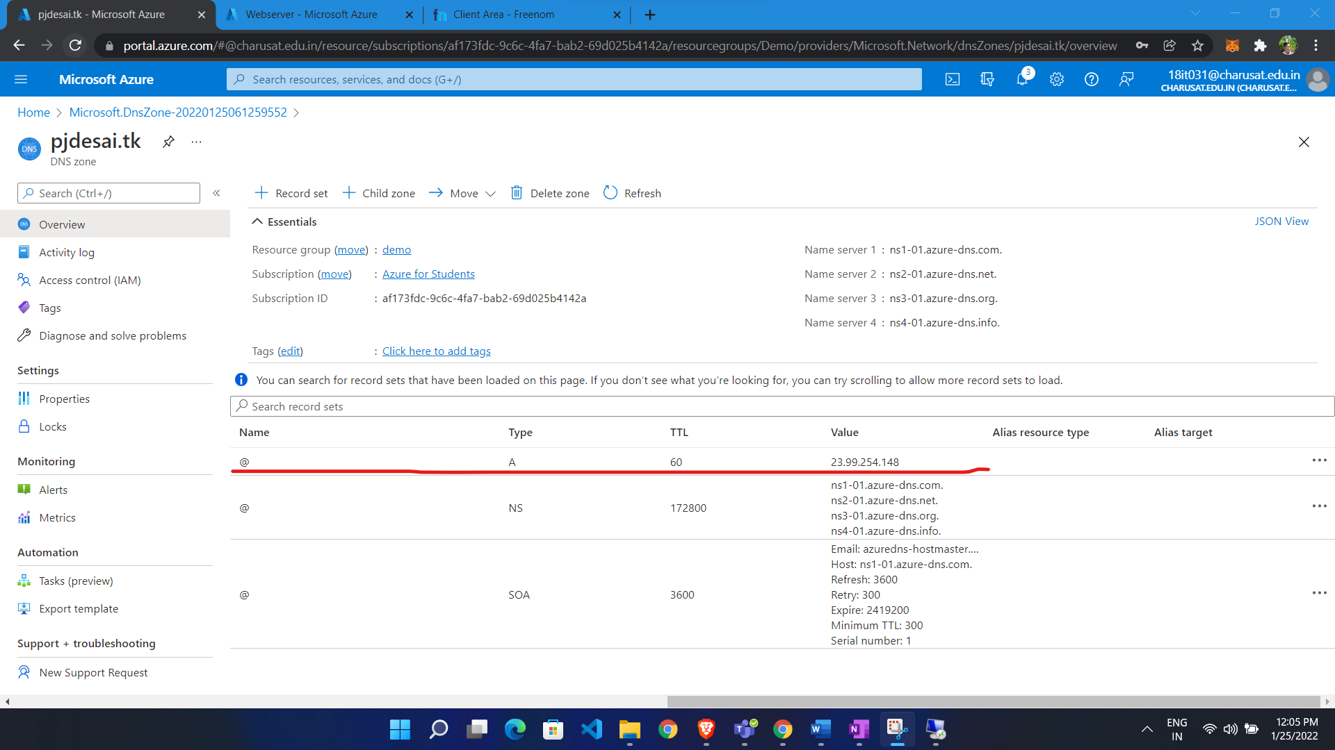

Now we access it

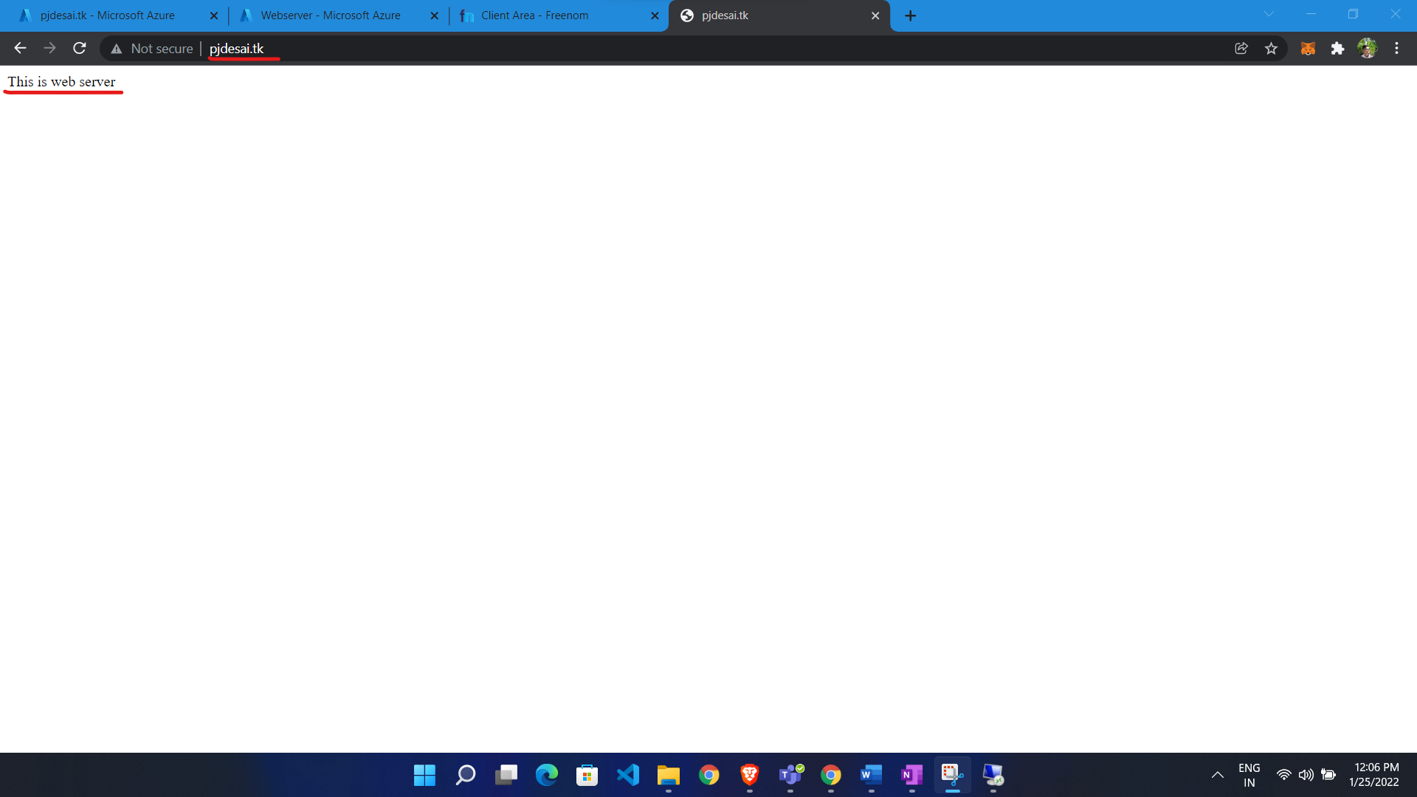

Make Alias Record:

* Go to public IP of VM
* Click configuration from left side
* Click alias record
* Give name

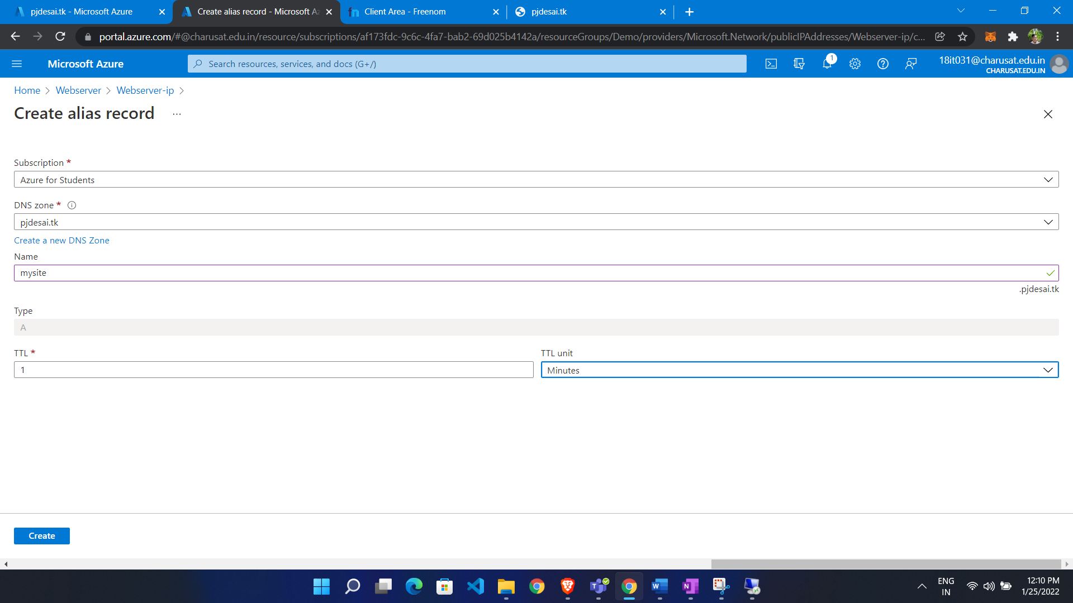

Record Add as alias record targeting to webserver-ip

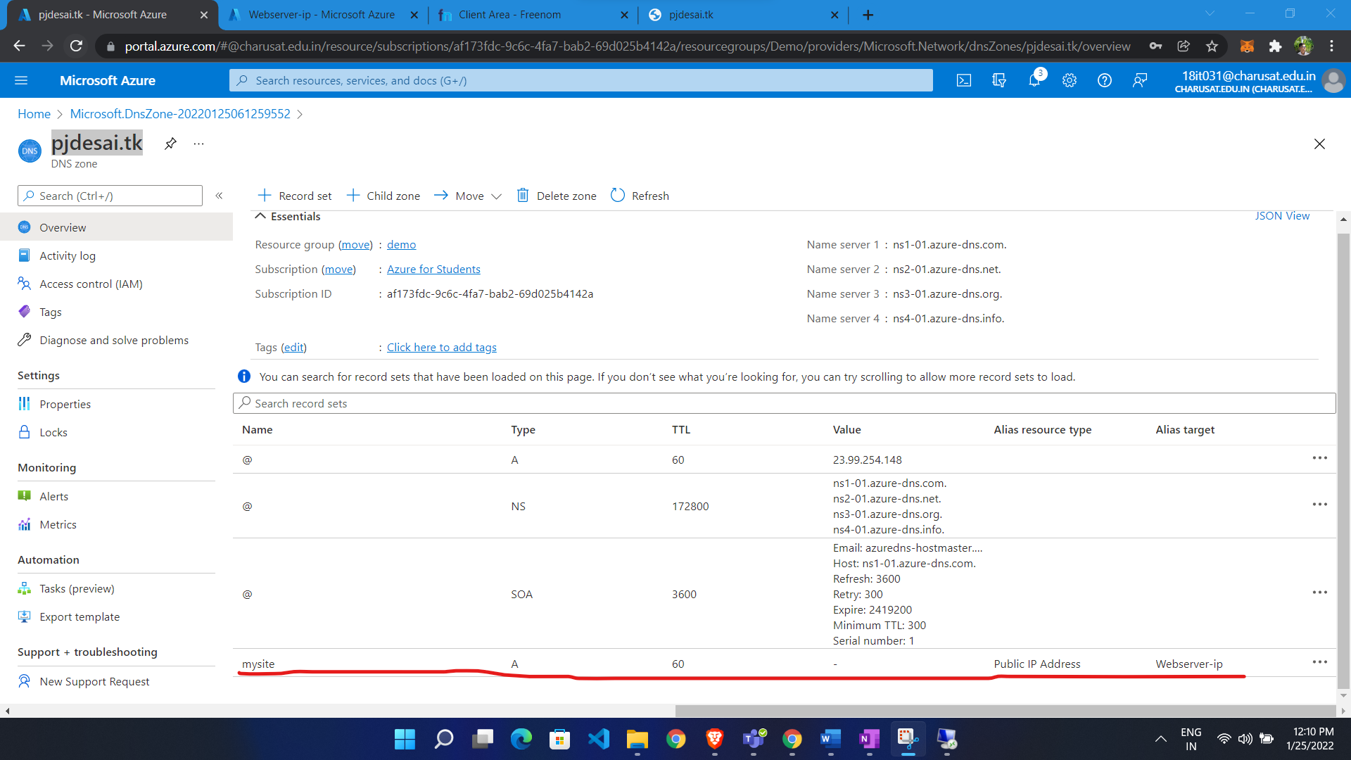

We get response from that

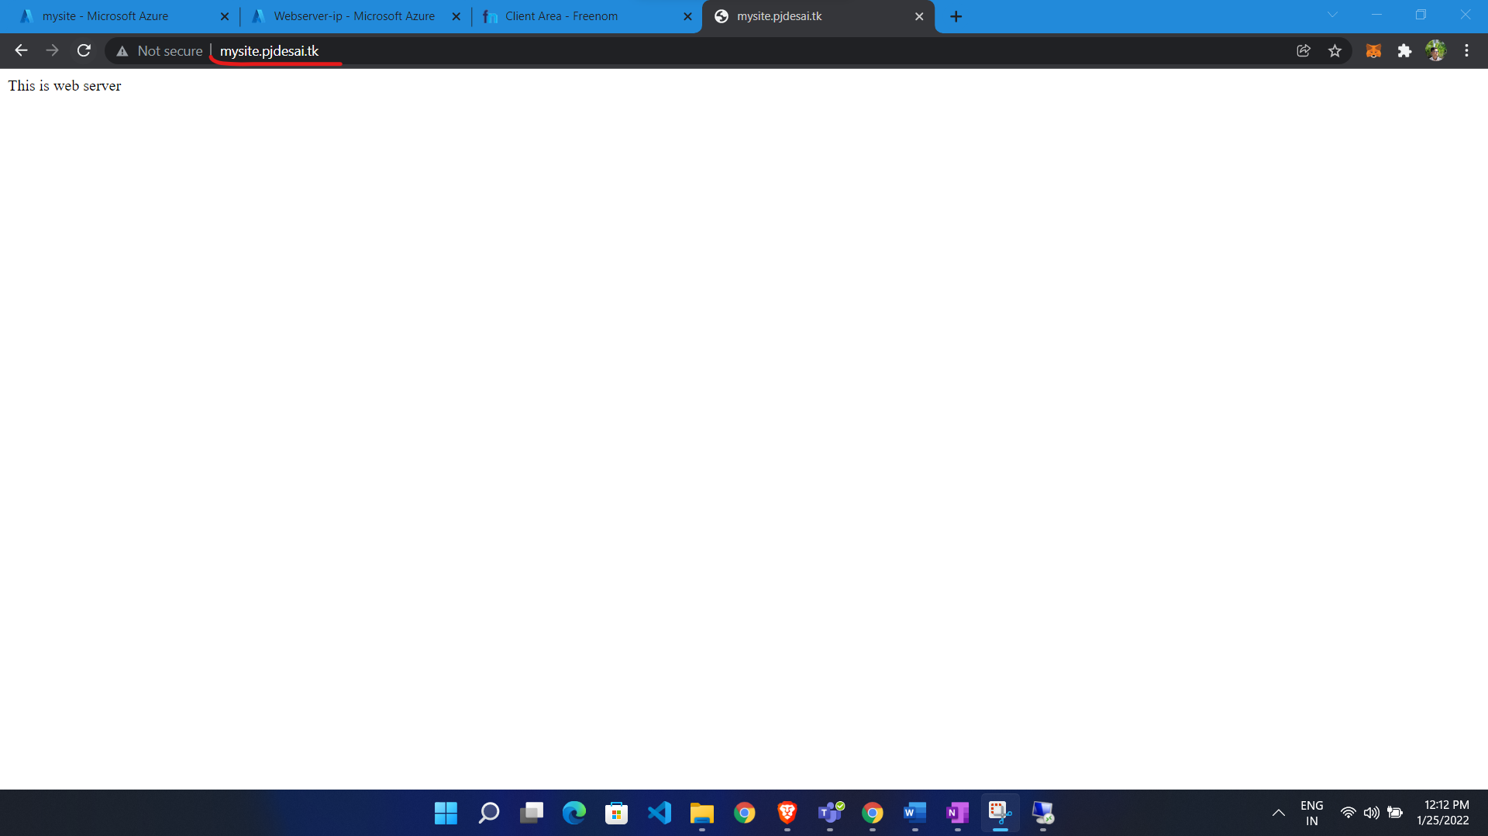

**Private DNS:**

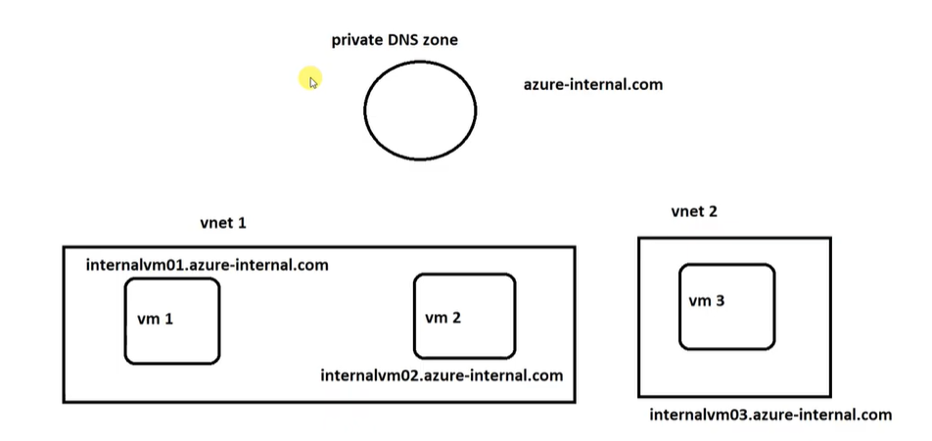

In private DNS we no need to purchase domain.

**Configuration:**

* Go to portal
* Search private DNS
* Click Private DNS
* Click create
* Select resource group
* Give name of domain
* Choose location

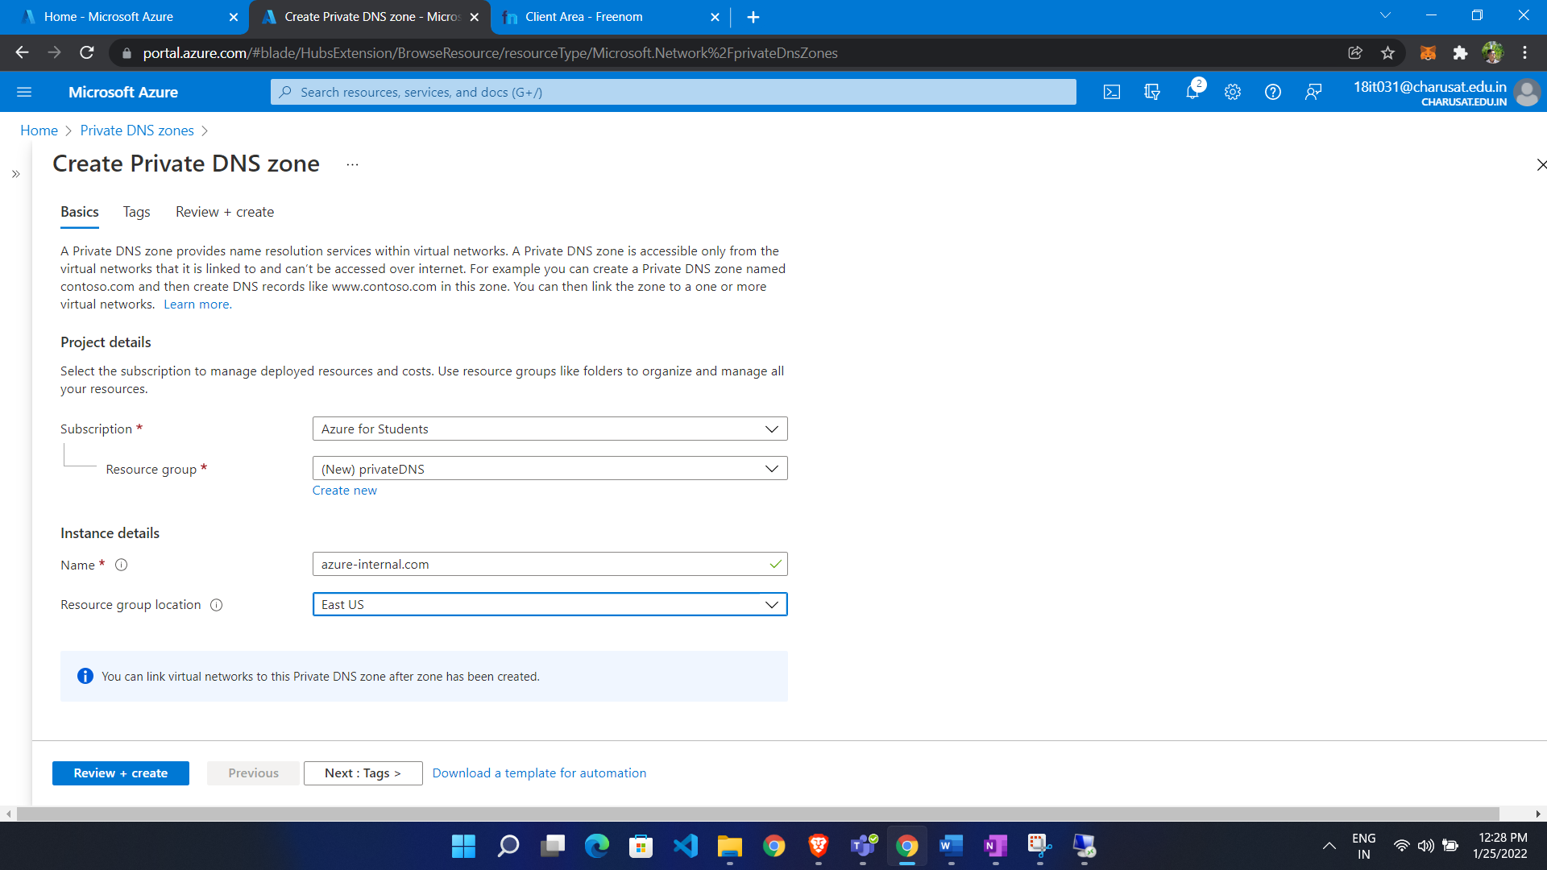

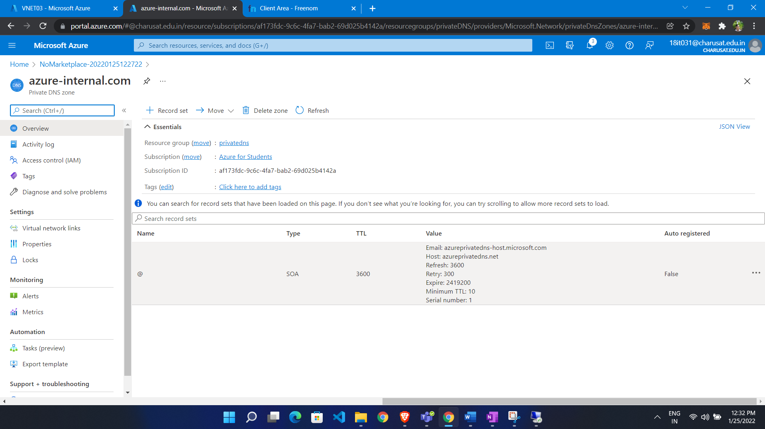

Create 2 VNET

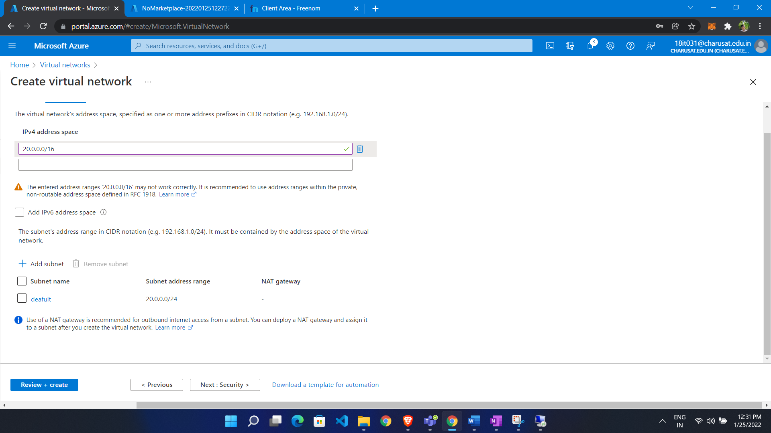

Now add 2 Vnet to private DNS Zone

* Go to vnet
* In left side menu click vnet link
* Click ADD
* Give link name
* Select VNET
* Check enable auto configuration ( it will help when we add vm to vnet it automatically add to record set)

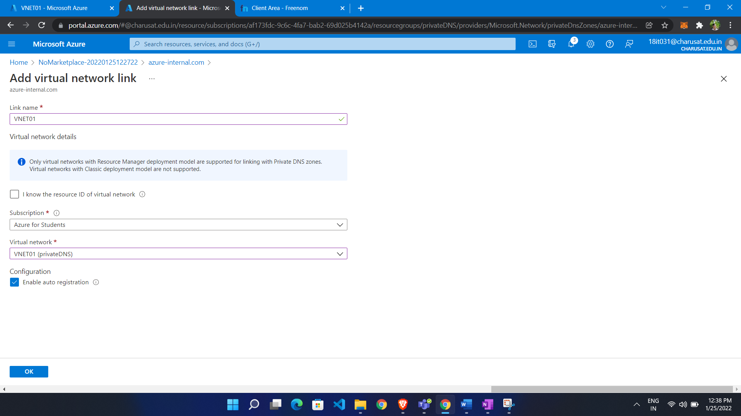

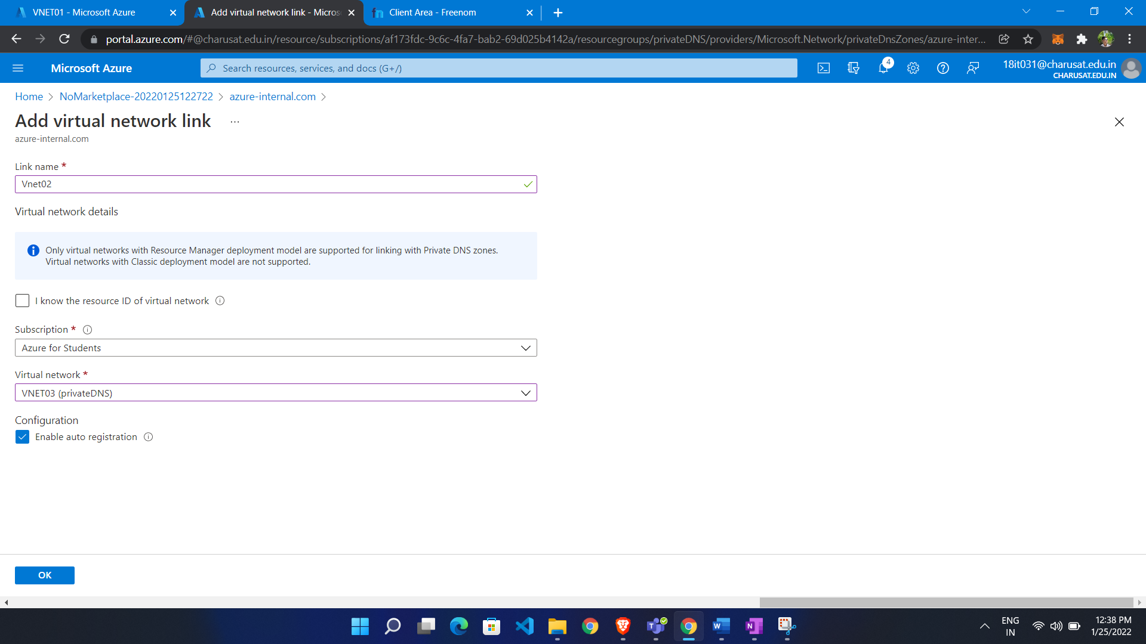

Now make 2 vm in 2 different VNET

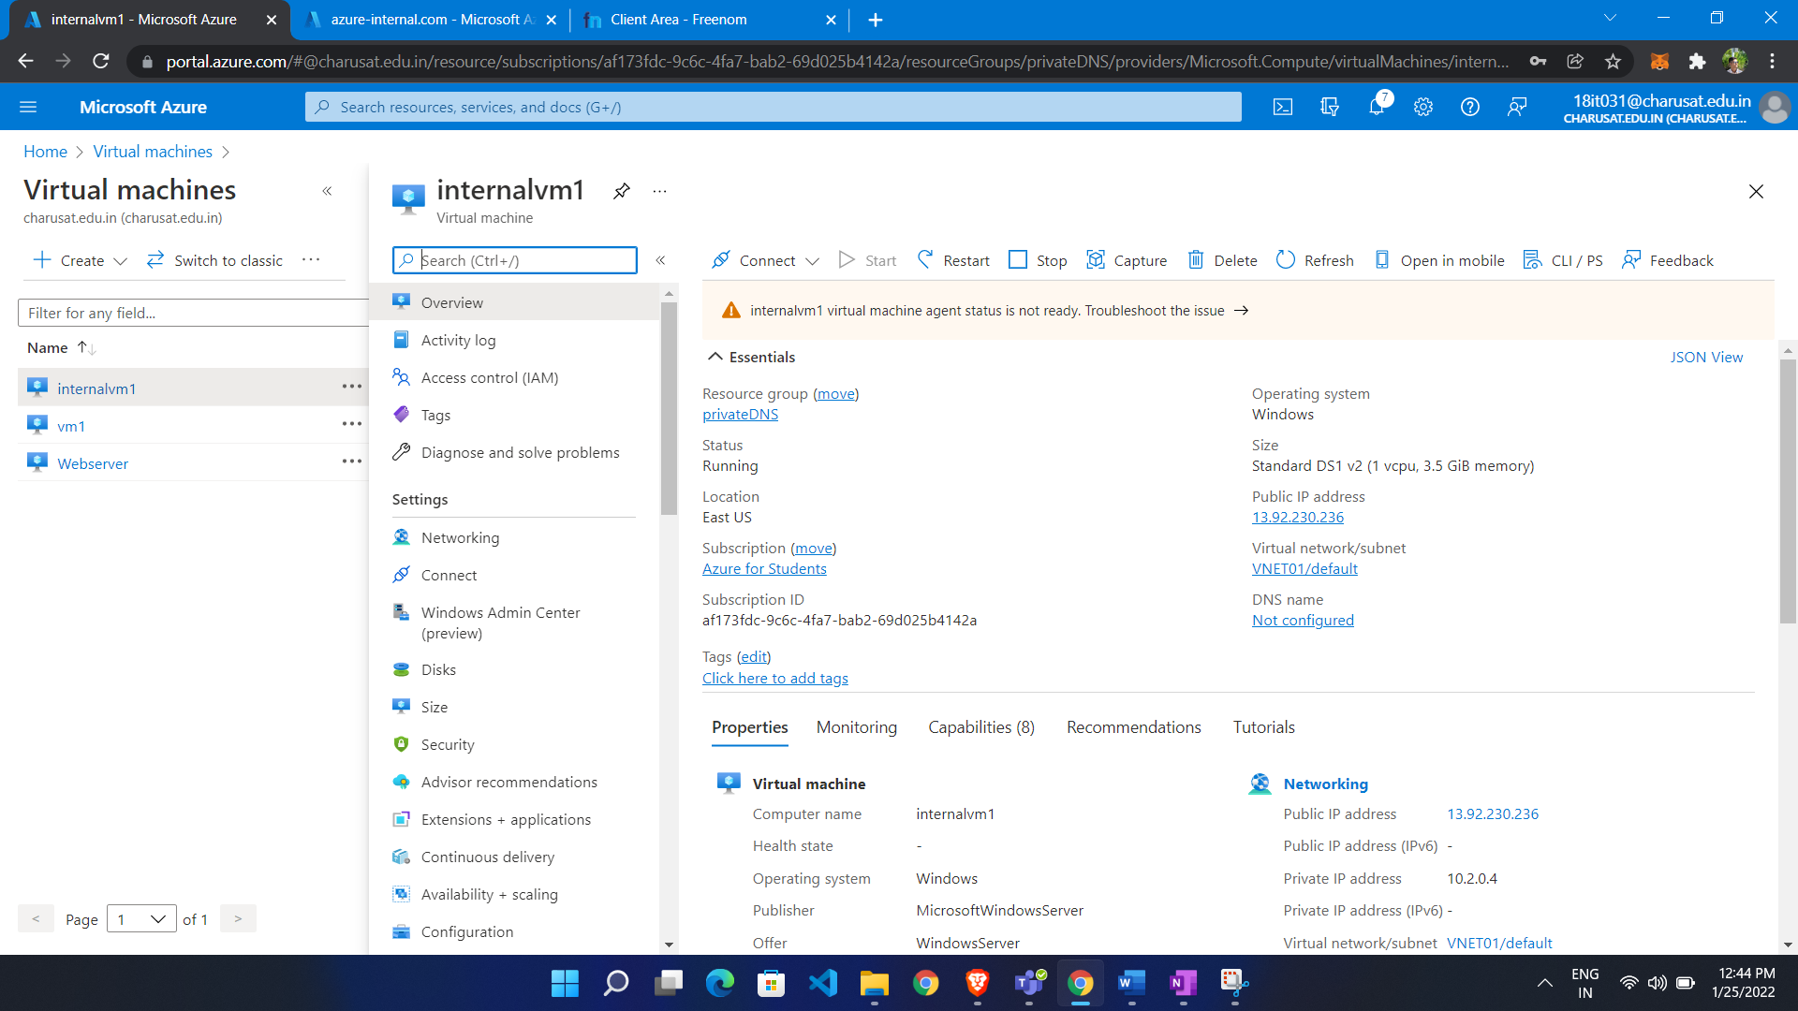

Add inbound port 80 and add IIS server

Now we have 2 vm in different vnet

* Go to vnet
* Click peering
* Click ADD
* Add name
* Also add remote link name
* Select vnet

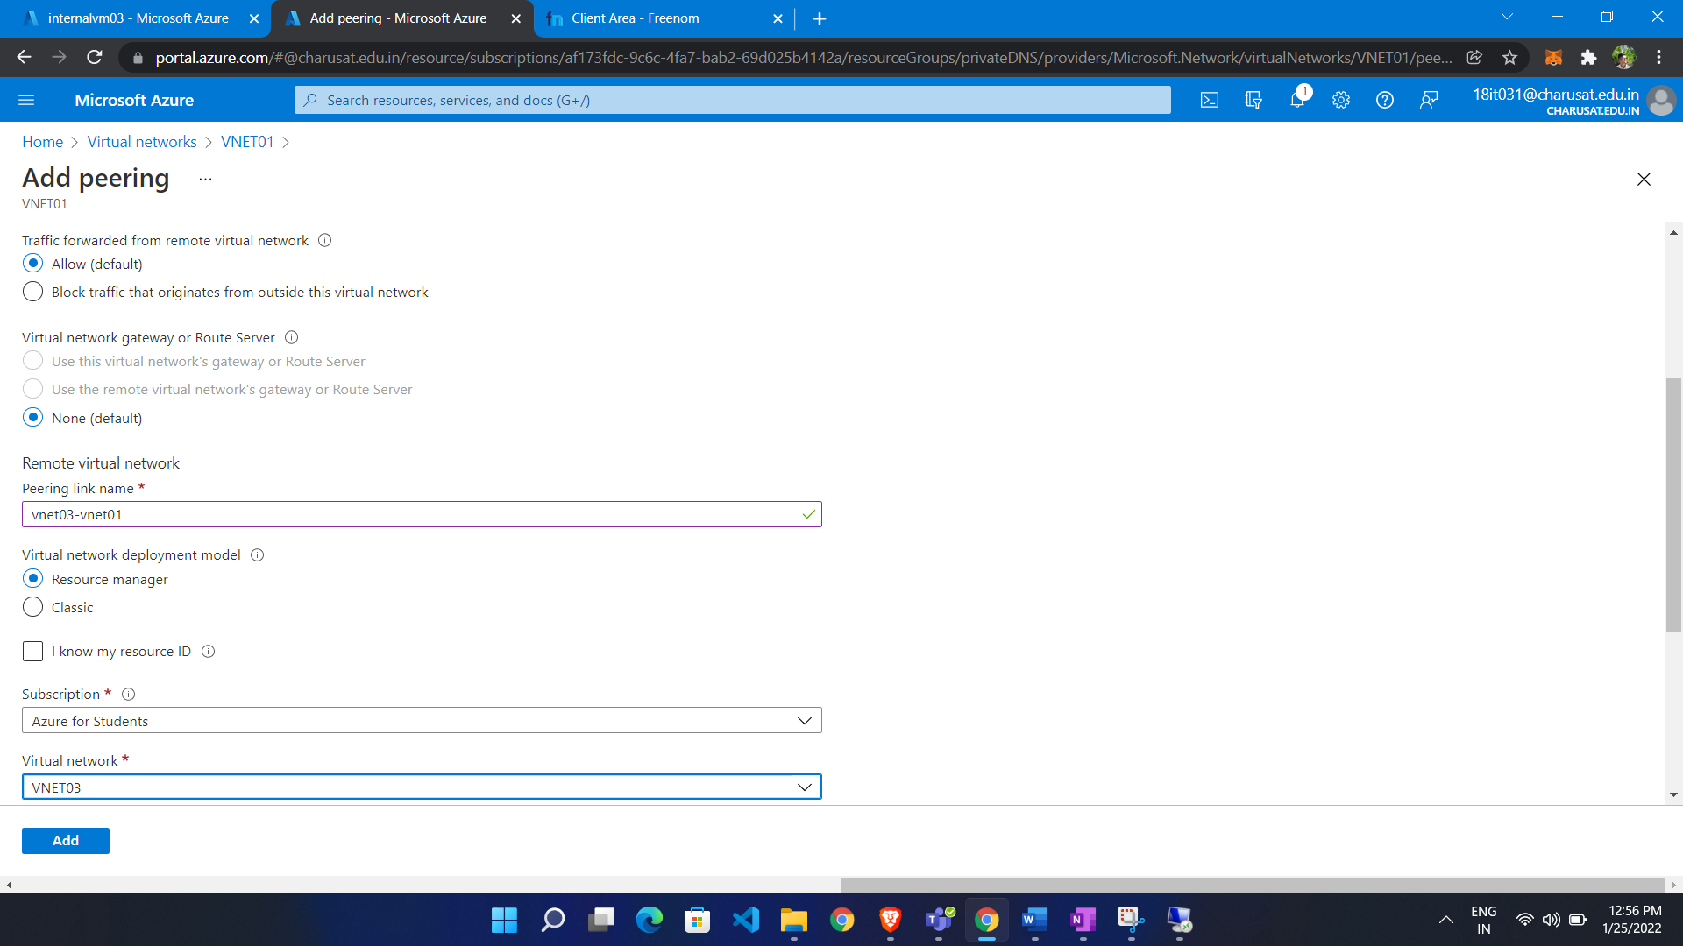

Now give DNS name to VM

* Go to private DNS

We see to entry there

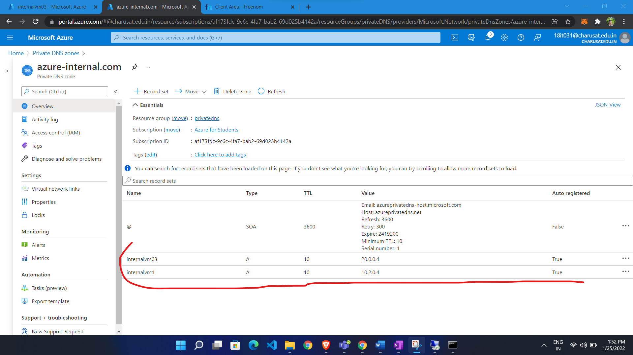

We are able to ping

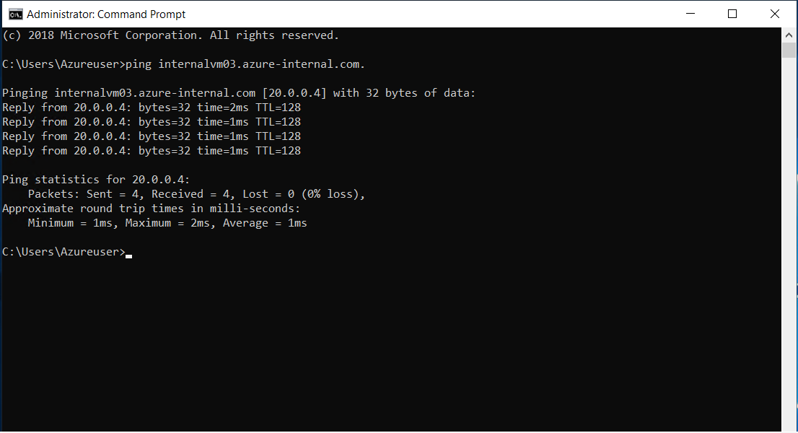

Own DNS Server:

Configuration:

Create 2 vm in on VNET

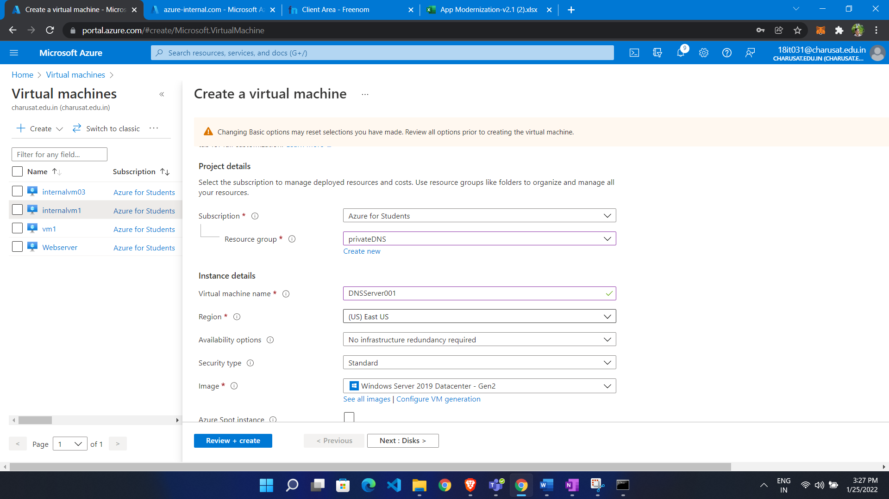

Add DNS Server role to VM (DNS VM)

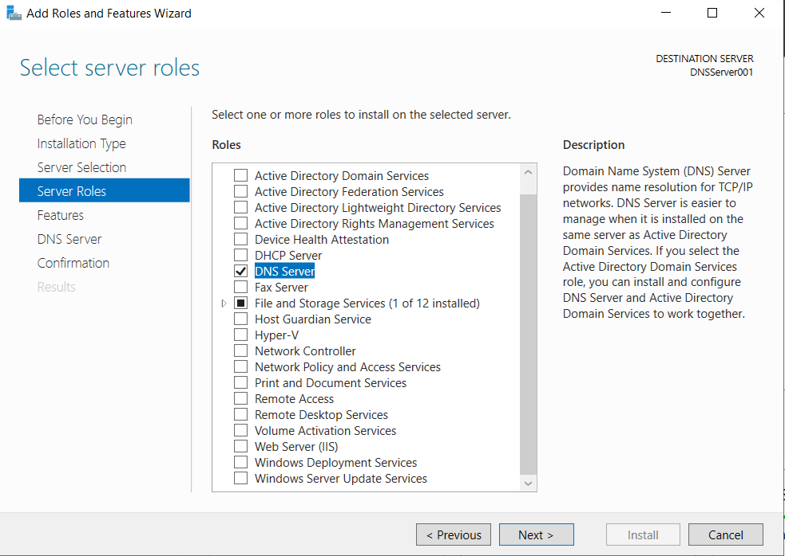

* Now go to server manager
* Go to tool
* In that click dns

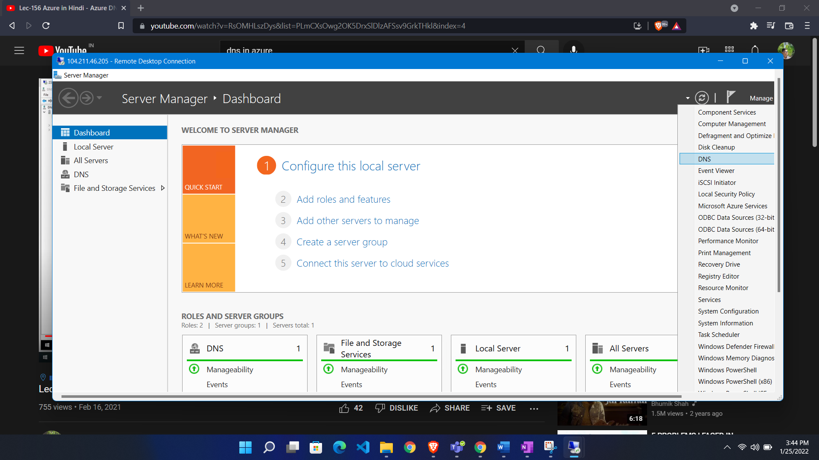

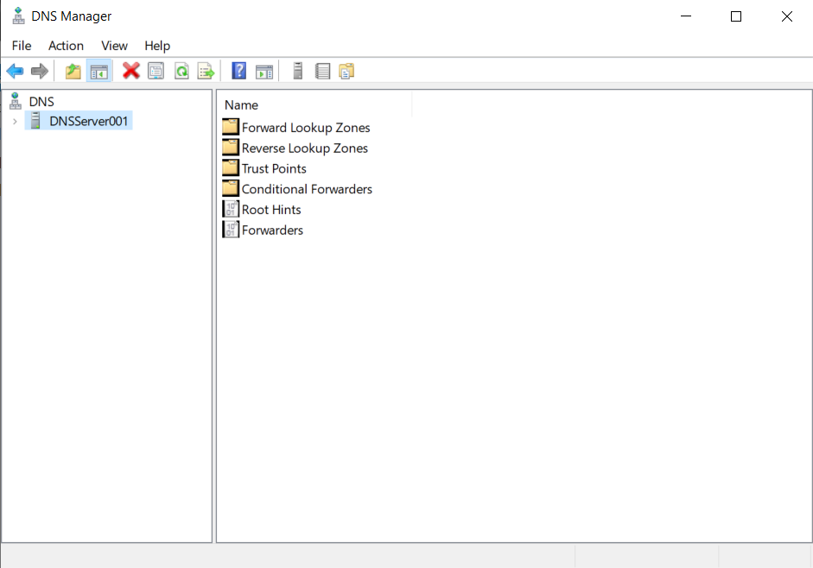

Go to forward lookup zone click add

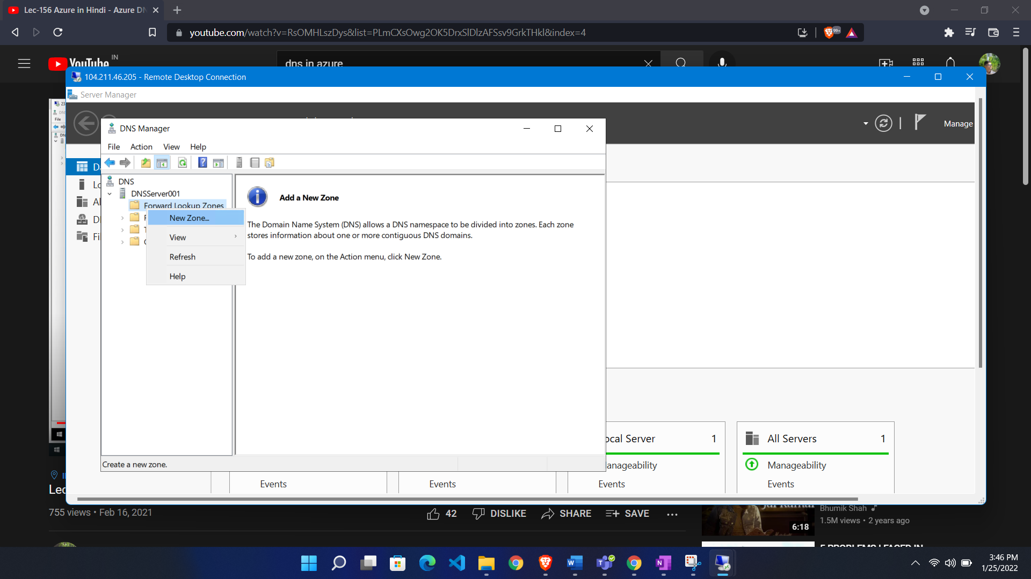

* Select primary
* Give name (custom domain name)

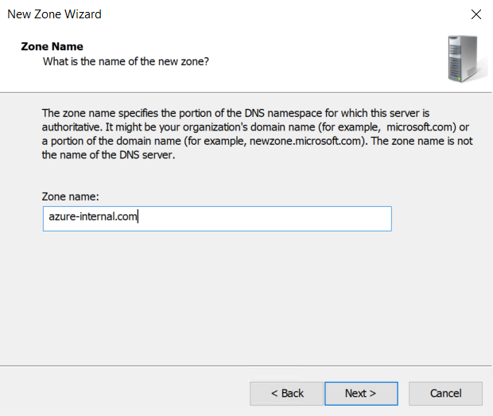

If we have our DNS server than we register it in vnet

* Go to vnet
* In left side menu select DNS
* Choose custom
* Add private ip of DNS server

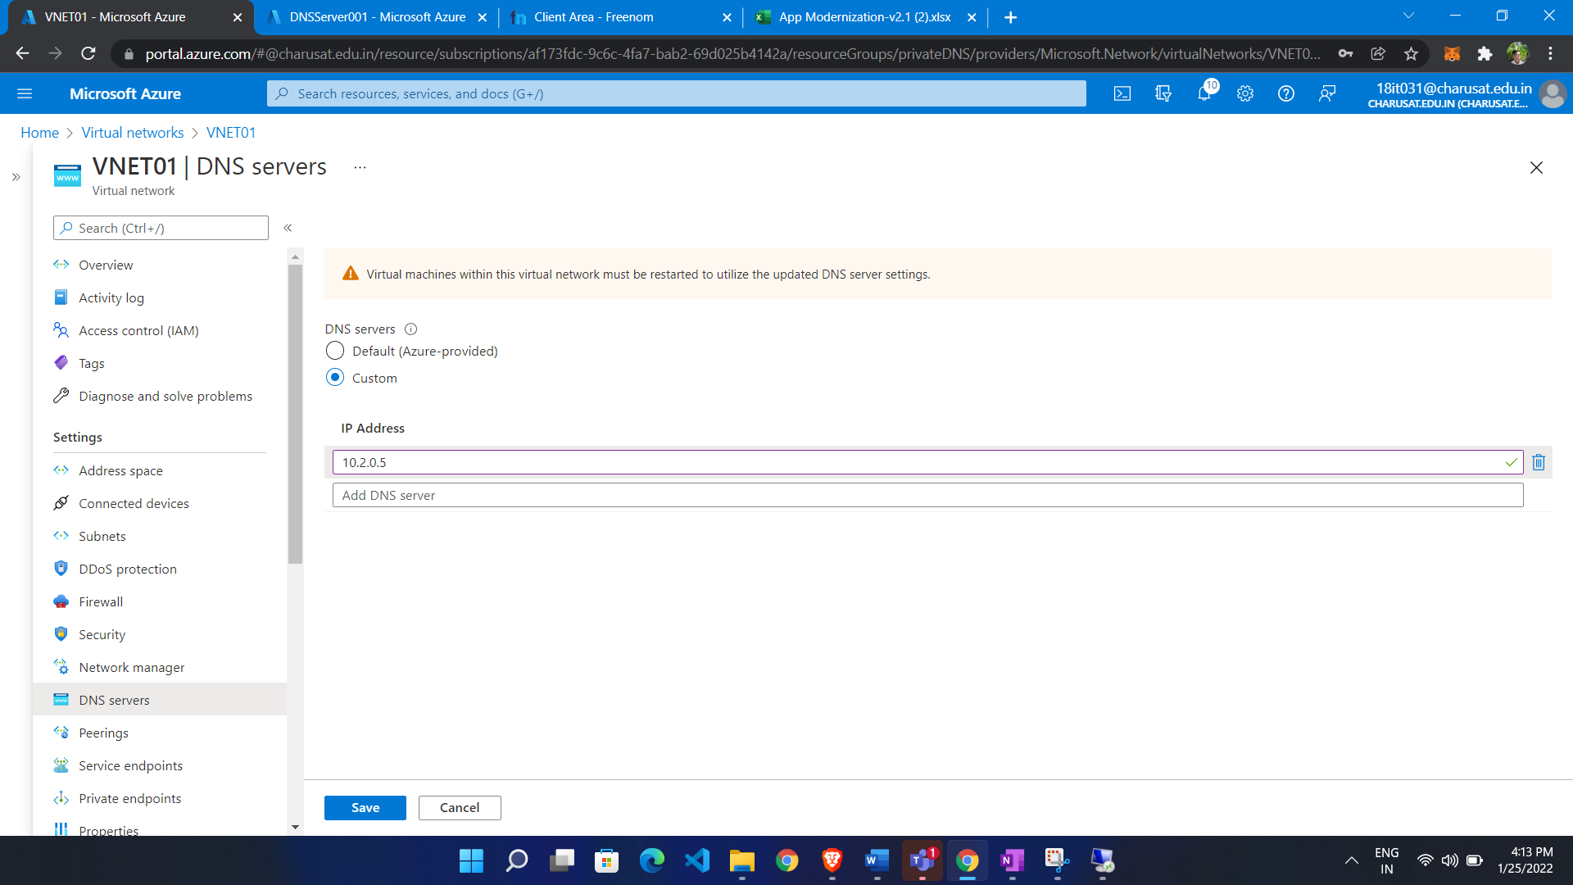

Now Add new record to DNS server

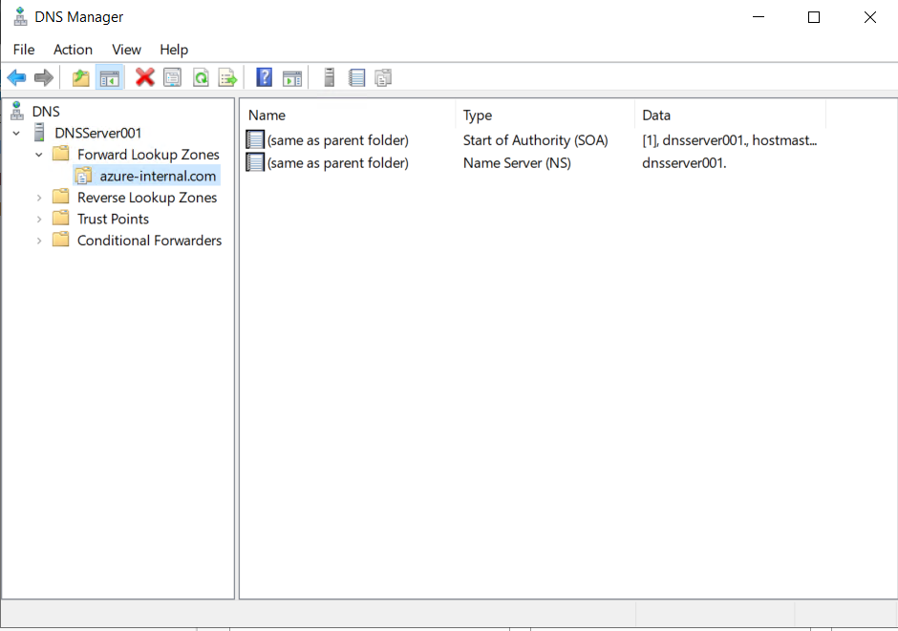

Give name of webserver

Add ip (private ip)

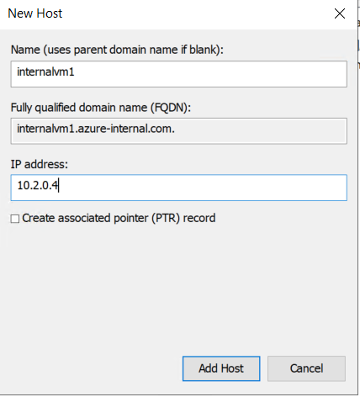

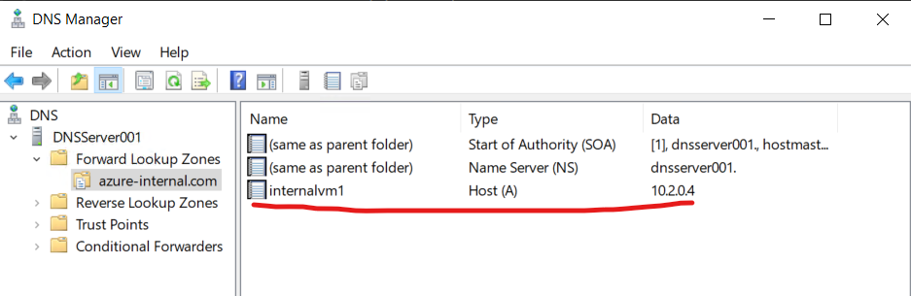

Access through custom DNS Name

